USN | 1 | M | S
M S RAMAIAH INSTITUTE OF TECHNOLOGY
(AUTONOMOUS INSTITUTE, AFFILIATED TO VTU)
BANGALORE – 560 054
SEMESTER END EXAMINATIONS – MAY/JUNE 2016

Course & Branch | : | B.E. – Electrical & Electronics Engg. | Semester | : | VI
Subject | : | Linear Integrated Circuits | Max. Marks | : | 100
Subject Code | : | EE604 | Duration | : | 3 Hrs

Instructions to the Candidates:
- Answer one full question from each unit.
- Typical standard values of Resistors and Capacitors sheet allowed.
- Suitably assume the missing data if any.

 |  | UNIT-I
1. | a) | An inverting amplifier using 741 op-amp has input resistance = 18 KΩ and feedback resistance = 180 kΩ. Calculate the minimum input impedance and output impedance of the inverting amplifier. (From 741 op-amp data sheet open loop voltage gain = 2,00,000, open loop output impedance = 75Ω, open loop input  impedance = 0.3 MΩ) | C01 | (04)
 | b) | Determine the output voltage for the open loop non inverting amplifier circuit given in fig. 1.(b), if  i) V_{in(rms)} = 35.35 µV (rms value of the sine wave a.c input voltage)  ii) V_{in} = 20 mV (d.c. input)  Draw the input and output waveform for both the cases.  Op-amp used is 741 op-amp with a supply voltage of + 15V  (open loop gain of op-amp is 2,00,000)  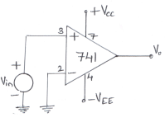  1.(b) | C01 | (06)
 | c) | i) The difference of two signal which each range from 0.1 V to 1V is to be amplified by a factor of 15. Using 741 op-amp, design a suitable difference amplifier. Determine the differential input resistance and common mode input resistance.  ii) Modify the circuit designed in (i) to give approximately equal input resistance at the two input terminals and to provide output voltage nulling.  Draw the circuit for (i) and (ii) separately with component values mentioned on it. | C03 | (10)
2. | a) | The circuit in fig. 2(a) uses a 741 operational amplifier and has  R₁ = R₂ = 39KΩ with a resistor tolerance of + 5%. Determine the maximum input offset voltage due to (i) the 741 op-amp input offset current (ii) the resistor tolerance (From 741 data sheet input offset current = 200 nA; Bias current = 500 nA)  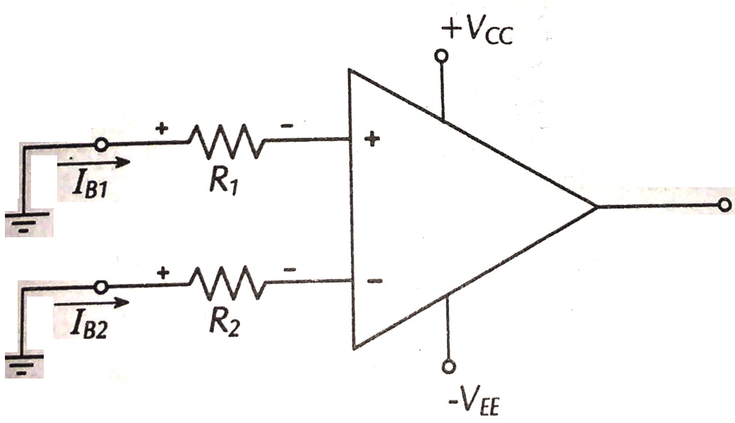  Fig. 2(a) | C01 | (04)
 | b) | Explain how slew rate of an op-amp can introduce distortion in the output waveform. | C01 | (06)
 | c) | For a non inverting amplifier as shown in Fig. 2(c) determine  i) A_{V} ii) V₀ iii) I_{L} iv) I₀ (I_{B} = 500nA)  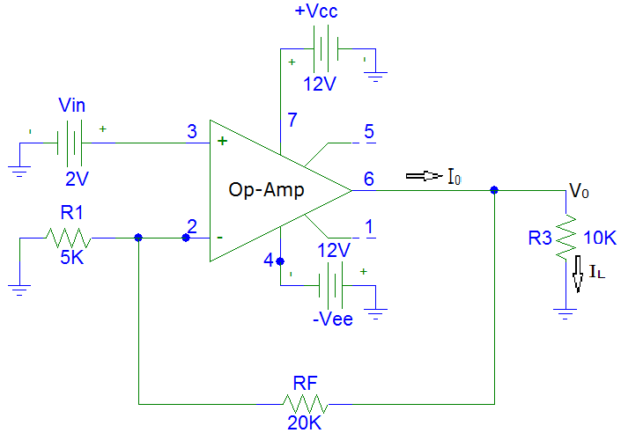  Fig. 2(c) | C01 | (08)
 | d) | A signal applied to a voltage follower is to be developed across a load with a maximum signal loss of 0.005%. Determine the minimum open loop gain of a suitable op-amp. | C01 | (02)
 |  | UNIT – II
3. | a) | A capacitor coupled voltage follower using a 741 op-amp is to have an input impedance of 12 KΩ. The lower cutoff frequency is to be a maximum of 100 Hz and the load resistance can vary from 3.3 KΩ to 15 KΩ. Design a suitable circuit. Draw the circuit with component values mentioned on it. | C03 | (06)
 | b) | Using a bipolar op-amp design a plus and minus precision clipping circuit to clip the output at a level adjustable from 2V to 5V. The reference voltage is to be derived from the op-amp + 12 V power supply. Draw the circuit with component values mentioned on it. | C03 | (14)
4. | a) | The capacitor coupled non inverting amplifier given in fig. 4(a) has the following component: R₁ = R₂ = 180 KΩ, R₃ = 100 KΩ, R₄ = 10 KΩ,  C₁ = 0.047µF, C₂ = 0.47µF, C₃ = 0.047µF and C_{F} = 100 pF. Calculate:  (i) the single polarity supply voltage (ii) circuit lower and upper cutoff frequency (iii) the impedance of capacitors C₁, C₂, C₃ and C_{f},  (iv) voltage gain of the circuit (iv) the maximum input and the output voltage (v) the minimum value of load resistance that can be connected to the output of the circuit.  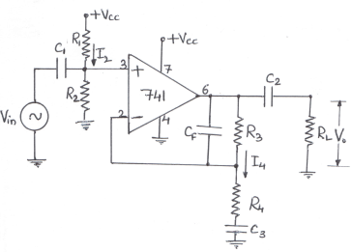  Fig. 4(a) | C02 | (10)
 | b) | With a neat circuit and waveforms, explain the working of op-amp sample and hold circuit. Discuss the holding time and acquisition time for an op-amp sample and hold circuit and write the equations for determining capacitor size and minimum acquisition time. | C02 | (10)
 |  | UNIT – III
5. | a) | With a neat circuit diagram explain the working of narrow band pass filter. Plot its frequency response curve and explain the step by step procedure involved in designing the filter. | C02 | (10)
 | b) | Design the triangular wave generator so that frequency of oscillation f₀ = 800 Hz and V_{0(P-P)} = 10V. Use 741 Op-Amp with a supply voltage of + 12V. Draw the circuit diagram with component values mentioned on the circuit. Also sketch the expected waveform. | C03 | (10)
6. | a) | (i) Design a first order low pass filter to have a cut off frequency of 15 KHz with a pass band gain of 4. Draw the circuit diagram with component values on it.  (ii) On a semi log sheet, plot the frequency response curve of the low pass filter designed in (i).  (iii) Using frequency scaling technique, modify low pass filter designed in (i) to have a new cutoff frequency of 20 KHz. | C03 | (10)
 | b) | With a neat sketch explain the working of active notch filter. | C02 | (05)
 | c) | Design an RC phase shift oscillator for an oscillating frequency of 1 KHz. Draw the circuits with component values mentioned on it | C03 | (05)
 |  | UNIT- IV
7. | a) | Using a bi-polar op-amp design an inverting type Schmitt Trigger circuit to trigger at ±0.5V and to produce an output of approximately ±11V. Draw the transfer characteristics. | CO2 | (06)
 | b) | Sketch the circuit of a lead compensation network. Explain its operation and show how it affects operational amplifier frequency response. | CO1 | (06)
 | c) | List the precautions to be observed for opamp circuit stability. Briefly explain each one. | CO1 | (08)
8. | a) | Discuss overcompensation and explain its effects. | CO1 | (06)
 | b) | Show how the slew rate of an opamp can produce distortion in a sinusoidal otput waveform. | CO1 | (06)
 | c) | Design a non-inverting voltage level detector with hysteresis to have VUT=12V and VLT = 8V. Assume that ±Vsat = ±15V. | CO2 | (08)
 |  | UNIT – V
9. | a) | With a neat sketch explain the working of voltage to current converter with grounded load. Also derive an expression for the load current IL. | CO2 | (08)
 | b) | With a block diagram, explain the functioning of a Phase Locked Loop. | CO3 | (06)
 | c) | Design an adjustable voltage regulator to satisfy the following specifications: Output voltage Vo = 5 to 12 V, output current = 1A. Draw the circuit. | CO3 | (06)
10. | a) | With a neat block diagram and waveforms, explain the operation of timer IC 555 as a monostable multivibrator. | CO3 | (10)
 | b) | With the help of a neat circuit, explain the working of an integrator and draw its input voltage waveform, output voltage waveform and frequency response curve. Derive the expression for its output voltage. | CO3 | (10)
**********************

